FOR IMMEDIATE RELEASE: July 15, 2025

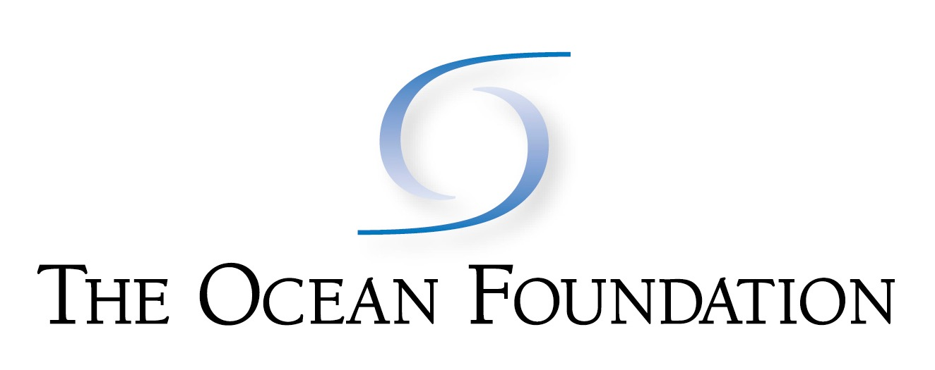

Coastal Coordination Program

Press Contacts:

Richard Charter,

Senior Fellow, The Ocean Foundation

707-696-1363

waterway@monitor.net

Sabrina Suluai-Mahuka

Executive Director

American Samoa Resilience Office

sabrina.mahuka@go.as.gov

**Comment Deadline Extended on**

**Seabed Mining at American Samoa**

**To Gather More Information**

*Pago Pago, American Samoa  -* Government officials and stakeholders today welcomed the announcement of an extension for receipt of public comments on the U.S. Bureau of Ocean Energy Management (BOEM) proposal for seabed mining at American Samoa, with a new comment deadline of August 15, 2025.

“Allowing time for sound science to be fully considered for this risky seabed mining plan should give decisionmakers a better opportunity to balance the cultural and ecological implications of industrial activities in the most sensitive part of our ocean with the inevitable industrial harm.” said Richard Charter, Senior Fellow with The Ocean Foundation. “Those affected by this proposal cannot rely only on corporate propaganda and false claims of sustainability during what has been a curtailed public comment opportunity.”

BOEM is required by law to consider the anticipated cultural and socioeconomic implications of the inevitable adverse impacts of ocean mining activities, such as potential impacts to Samoan culture or *Fa'aSamoa,* the Samoan way of life.  After reviewing the comments received, BOEM will decide whether to allow private companies to proceed with disruptive subsea mining activities.

Silt plumes and toxic pollution stirred up by giant robotic deep sea mining machines would threaten regional economies, vital fisheries, delicate corals, and unique deep ocean ecosystems essential to moderating Earth’s climate cycle. Additional high-impact seabed mining proposals are also being fast-tracked elsewhere throughout U.S. waters without considering resulting environmental damage that will last thousands of years.  The public comment period to express an opinion or submit new data on this proposal remains open at <http://savethedeep.org/>

The proposed deep sea mining would put at risk a region impacting Swains Island that noted marine scientist Jean-Michel Cousteau called “One of the Last Jewels of the Planet”.

This anticipated leasing action is in disregard of American Samoa’s Executive Order 0006-2024, which implements a moratorium on deep seabed mining exploration and exploitation activities.

The Rose Atoll National Wildlife Refuge is located only 180 miles east of Tutuila in American Samoa, and the proposed lease area is adjacent to the National Marine Sanctuary of American Samoa*,* thus boththe Refuge and the Marine Sanctuary are well within the range of ocean current transport of toxic pollution that would originate from the mineral extraction activities being proposed.

On July 2nd, Governor Pulaali'i Nikolao Pula shared, “As a government, we continue to act with caution and in the best interest of our people and environment. In 2024, the previous administration issued a moratorium on Deep Sea Mining activities until more information and protections could be ensured. Most recently, in June of this year, the American Samoa Government reaffirmed that position in a public statement. As Pacific Islanders, our ocean is a lifeline, and we do not take this issue lightly.”

Dr. Sabrina Suluai-Mahuka, Executive Director of the American Samoa Resilience Office, is spearheading the American Samoa Government DSM - Community Engagement Task Force to amplify the urgency of this comment period. Dr. Suluai-Mahuka added, “This is not just a policy issue; it’s a generational decision. The reality is that deep sea mining has the potential to pose irreversible risks to our ecosystems, our cultural identity, and our local economy. As stewards of these islands, we must be proactive, informed, and united in protecting what cannot be replaced.”

*end*